Assignment 09 :

Create appropriate indexes to solve the following problems.
Note: use “sales” database to solve below queries.

- Create an index that will enable a user to pull orders for ‘1990-10-03’ out of the Orders table quickly.
CREATE INDEX idx_orders_odate ON Orders(odate);
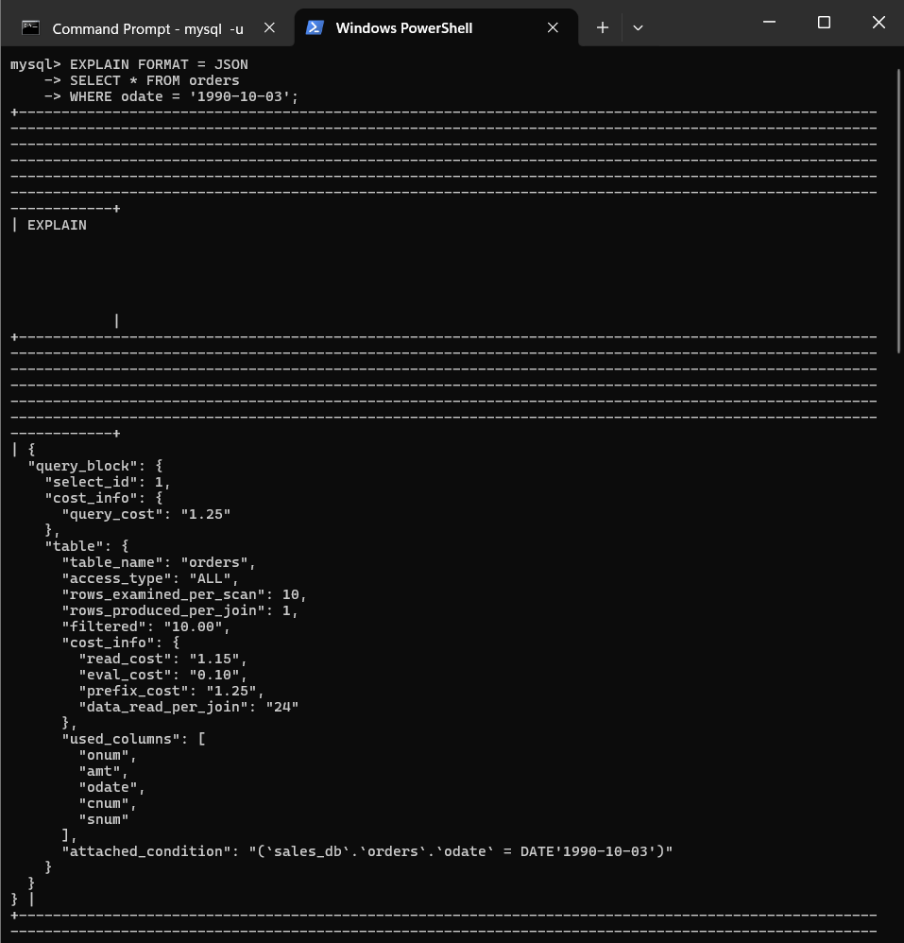
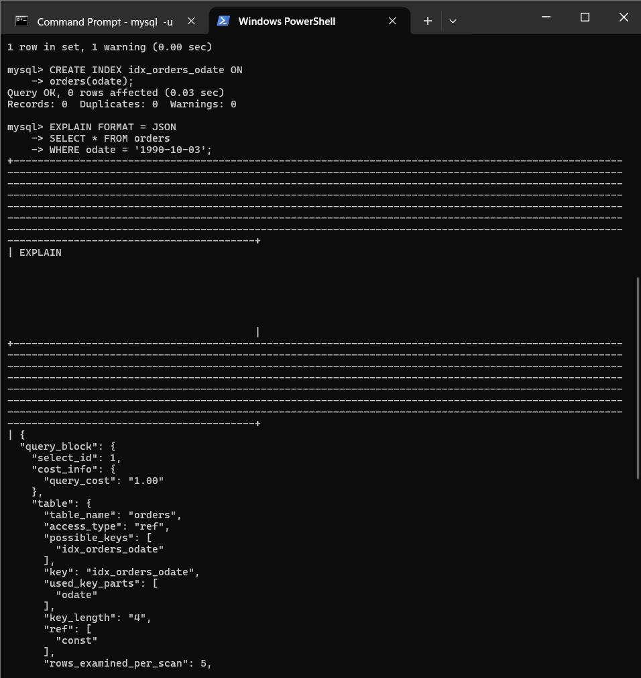

Query_Cost before : 1.25
Query cost after: 1.00

- If the Orders table has already been created, how can you force the onum field to be unique (assume all current values are unique)?

ALTER TABLE orders
MODIFY onum INT NOT NULL,
ADD CONSTRAINT uq_orders_onum UNIQUE(onum);
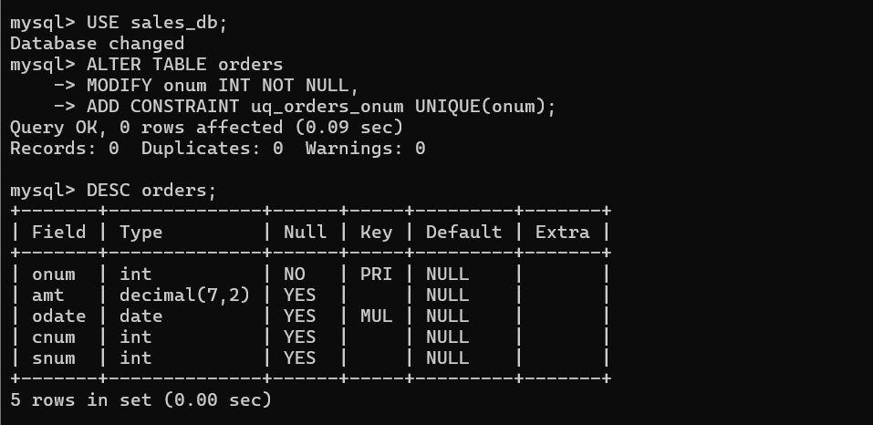

- Create an index that would permit salesperson to retrieve his orders.

CREATE INDEX idx_orders_snum
ON orders(snum);

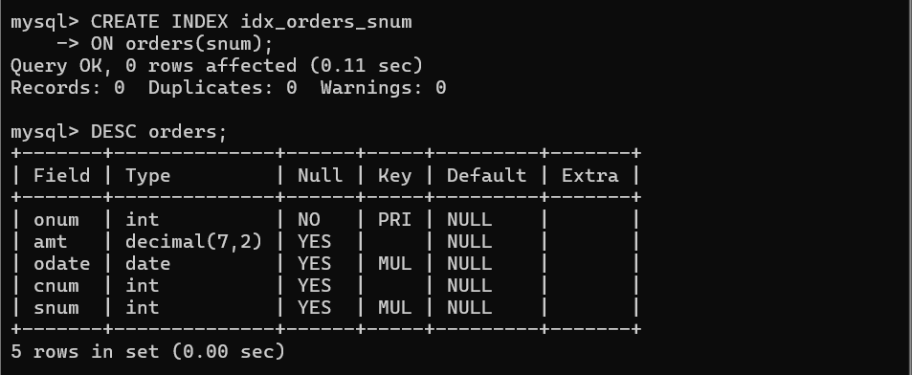

- Let us assume that each salesperson is to have only one customer of a given rating, and this is currently the case. Create an index that enforces it

CREATE UNIQUE INDEX idx_salespeople_customer_rating
ON customers(snum, cnum, rating);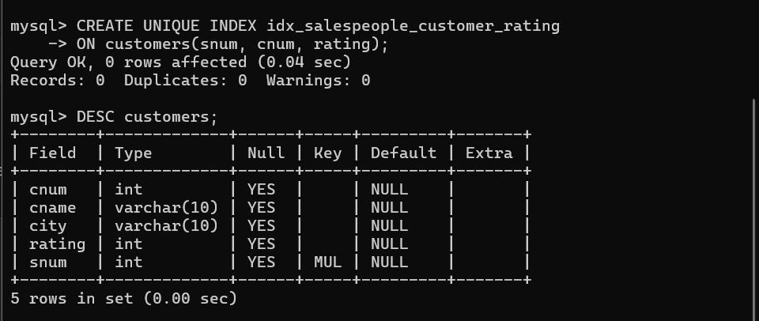

5. Create an index to speed up searching order on a given date by given customer.

CREATE INDEX idx_orders_cnum_odate
ON orders(cnum, odate);


